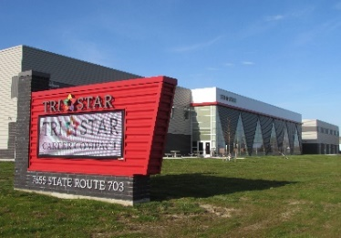
7655 State Route 703,
Celina, Ohio 45822
419-586-7060

Tri Star’s Fall Adult Classes 2021
Welding I Mondays & Wednesdays 5:00 – 8:00 p.m. $500.00 per person
Oct. 18, 20, 25, 27, Nov. 1, 3, 8, 10, 15, & 17 (includes equipment)
30 hours
FANUC Robotics Mondays & Wednesdays 4:15 – 7:15 p.m. $585.00 per person
Oct. 18, 20, 25, 27, Nov. 1, 3, 8, 10, 15, & 17 (includes book and exam)
30 hours
Computer Basics Suite Mondays & Wednesdays 4:00 – 6:00 p.m. $350.00 per person
1. Windows/Google Apps Oct. 18, 20, 25, 27
2. Beginning Word/Google Docs Nov. 1, 3, 8, & 10
3. Beginning Spreadsheets/ Nov. 15, 17, 22, 23
Google Sheets 24 hours
ServSafe Oct. 27, 28 & Nov. 1 4:00 – 8:00 p.m. $185.00 per person
12 hours (includes book and exam)

Machining/CNC To be announced
Fall Adult Special Interest Workshops
Twinkling Fall Tomato-Cage Tree Tuesday 6:00 – 8:00 p.m. $40.00
Oct. 12 (includes all supplies)
3-D Printing To be announced

REGISTRATION: Individuals will be considered registered once payment is received. Applications available on the Tri Star website at https://www.tristarcareercompact.com/documents/2021FALLTri-Star-ADULT-ED.-Application.pdf Questions? Contact Marcia Helentjaris at 419-586-7060 or Marcia.Helentjaris@tristarcc.org
Tri Star Career Compact reserves the right to cancel any class lacking minimum enrollment.

