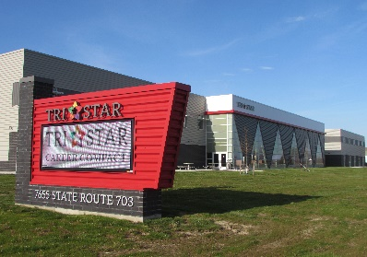
7655 State Route 703, Celina, Ohio
419-586-7060

Tri Star’s Adult Winter Schedule 2024
Machining/CNC
Mondays and Wednesdays 4:00-6:30 p.m. $600.00
February 5-March 18
Includes all equipment.
Small class size. Individualized attention.

Welding
Tuesdays and Thursdays 5:00-8:00 p.m. $600.00
February 1-March 5
Includes: helmet, welding jacket, leather gloves, MIG pliers, welding cap
Small class size. Individualized attention.

Robotics/FANUC
Tuesdays and Thursdays 3:30-6:30 p.m. $600.00
January 23-February 22
Small class with each student using their own robot.
Includes book and exam.
Earn national FANUC certification upon successful completion.

REGISTRATION
Individuals will be considered registered once payment is received.
Must call 419-586-7060 to register.
Questions? Contact Marcia Helentjaris at 419-586-7060 Marcia.Helentjaris@tristarcc.org
*All class schedules will be posted to www.tristarcareercompact.com and Facebook
*A certificate of completion will be presented to all students.

Tri Star Career Compact reserves the right to cancel any class lacking minimum enrollment.

